

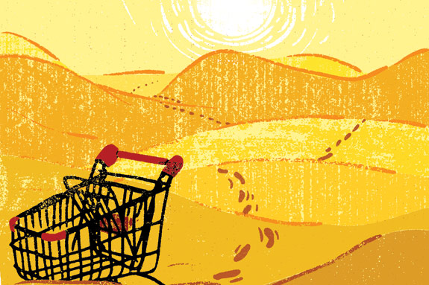

Ending Food Deserts

Who2Who

connecting

Who 2 who



© smiletrust

Who 2 Who is a mobile platform designed to help connect people ***Who*** need food to people ***Who*** have food through the Smi)etrust.

Team GCSDD 2020 renamed: ***‘The West Coast Team’***

Christian Dunham

Melinda Johnson

Sophia He

Imagine being born in a first world country as a second class citizen with third world problems.

Problem narrowed

How do we over come the racial technology gap to make it easy for people in impacted communities to access basic human needs from donor allies?

*One design rational* : application over website. In direct response to the technology inequality we chose to design an application that is beyond simple. Have you ever tried to sign up for blue apron?

*One Request* : Coordination to conduct 3-5 persona interviews with impacted user groups before the first bi-weekly meetup.

*Who 2 who* shop

User STories

What can *Who 2 Who* do?

**User:**

As a user I can log into SmileTrust

As a user I can see available items in my geographic area

As a user I can order items to be delivered to my home location

As a user I can request items not available

**Donor Ally:**

As an donor ally I can log into SmileTrust

As a donor ally I can submit items (groceries, funds) as available to *Who 2 Who* in my geographic area

As a donor ally I can see requests for items in my area

**Shop Ally:**

As a *Who 2 Who* Shop Ally I can add geographic areas of availability

As a *Who 2 Who* Shop Ally I can add items from a donor to a geographic inventory

**Domain Rel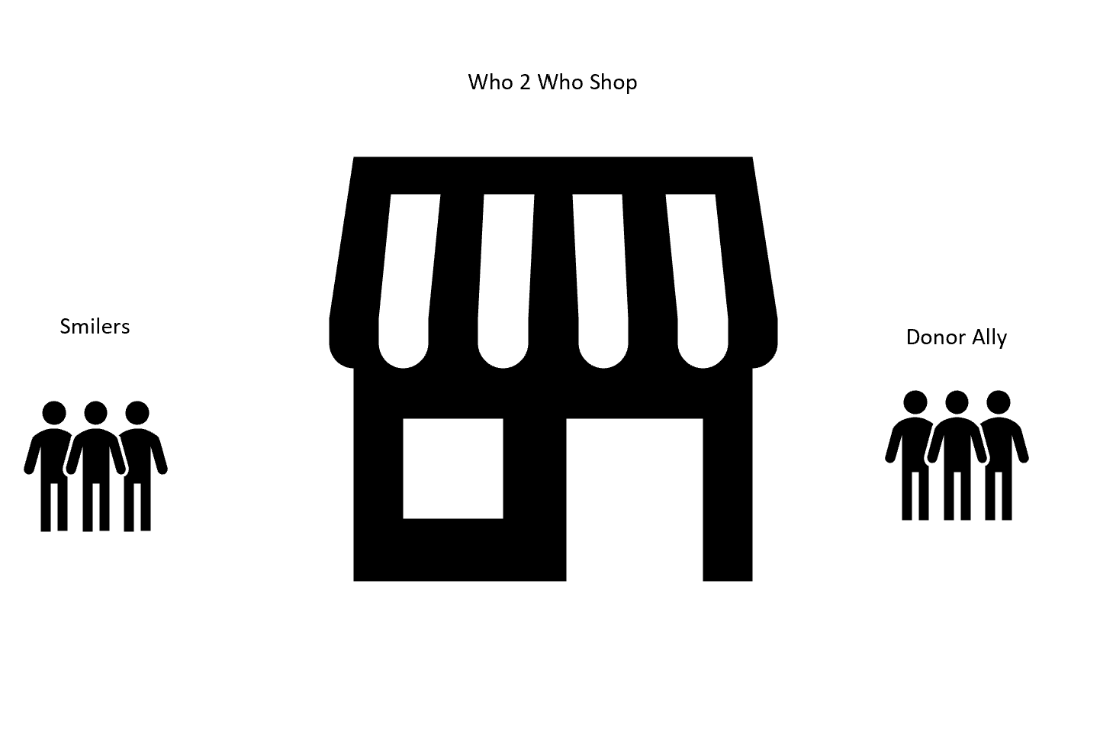ationships**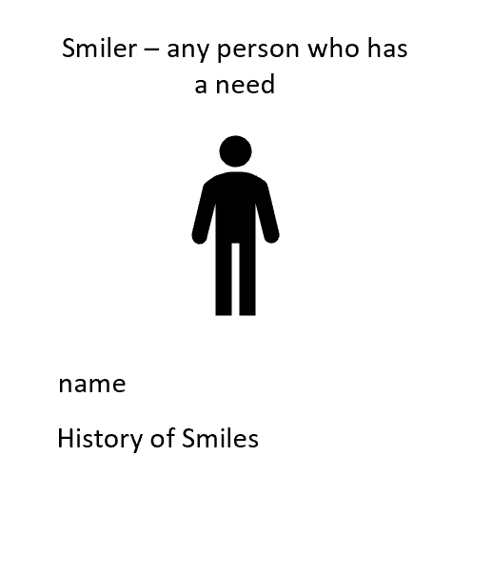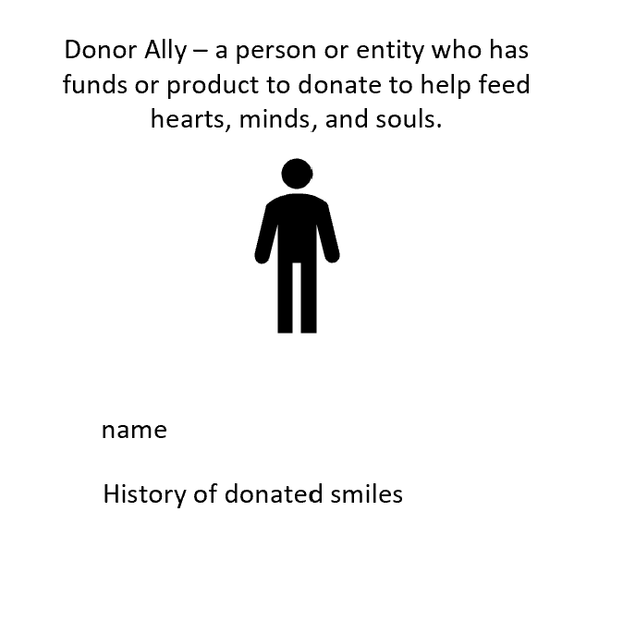

Who 2 Who Shop Domain

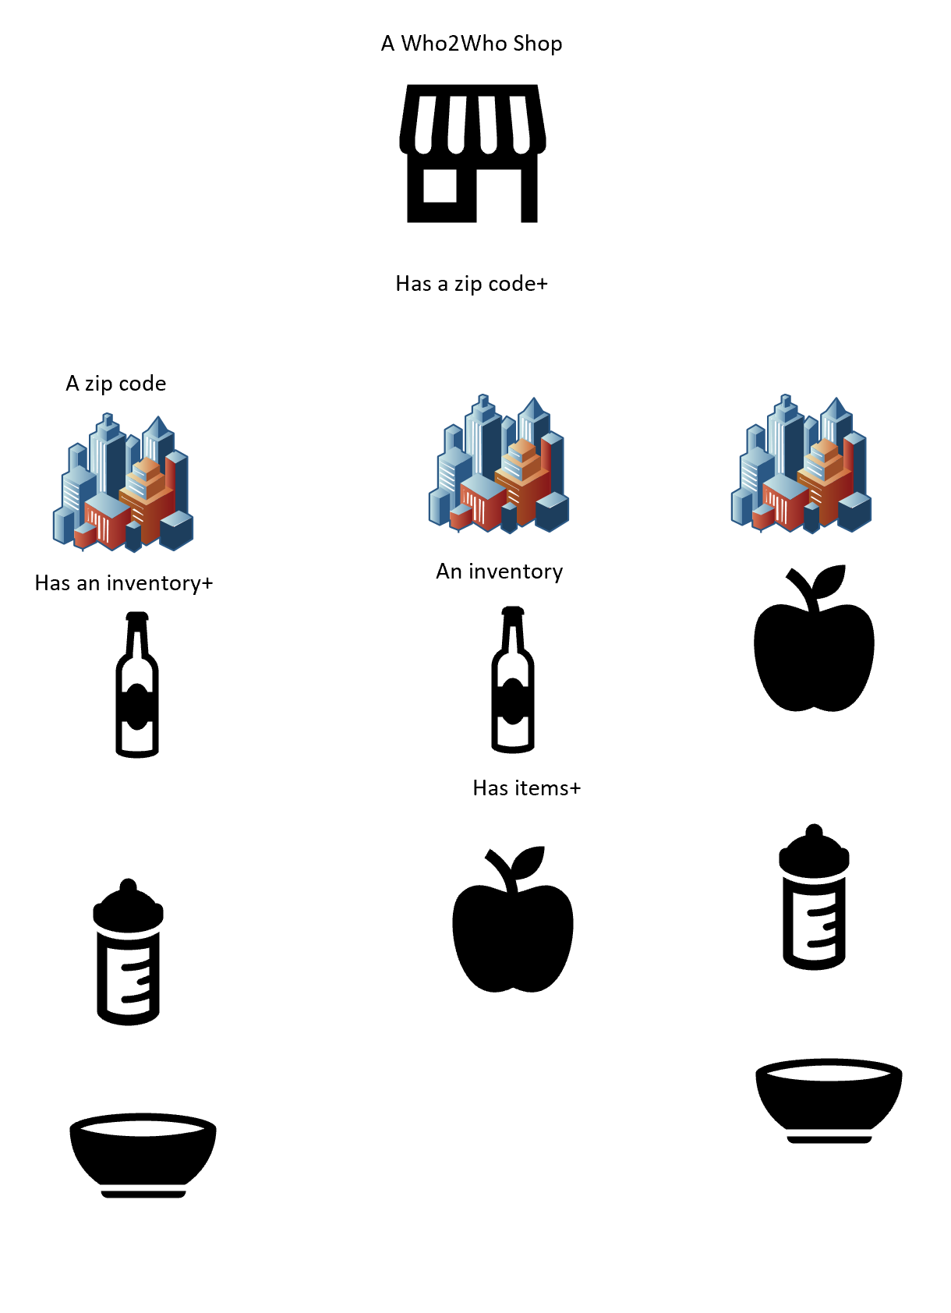

Smiler Flow 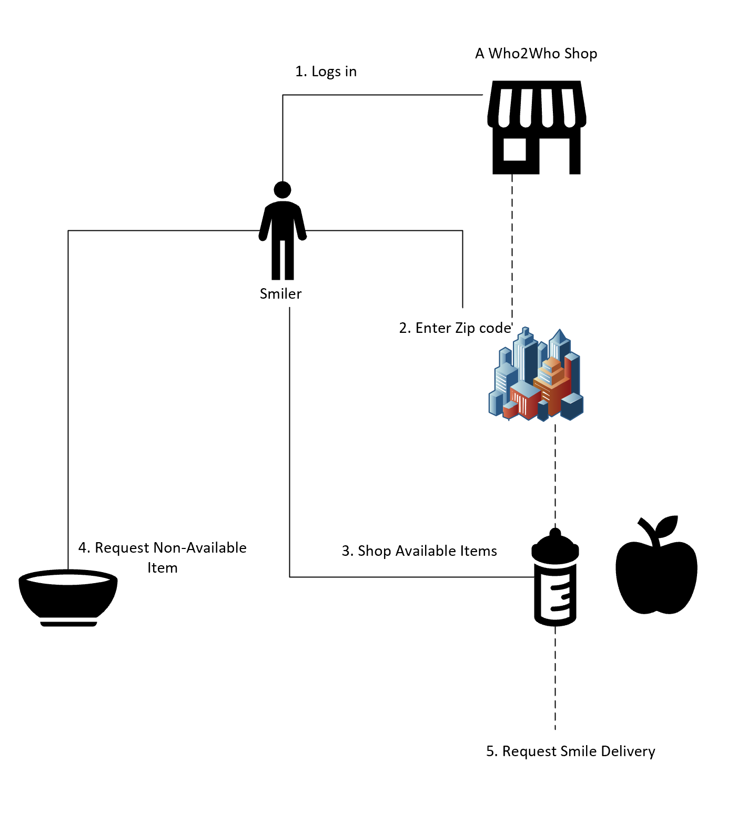

Donor Ally Flow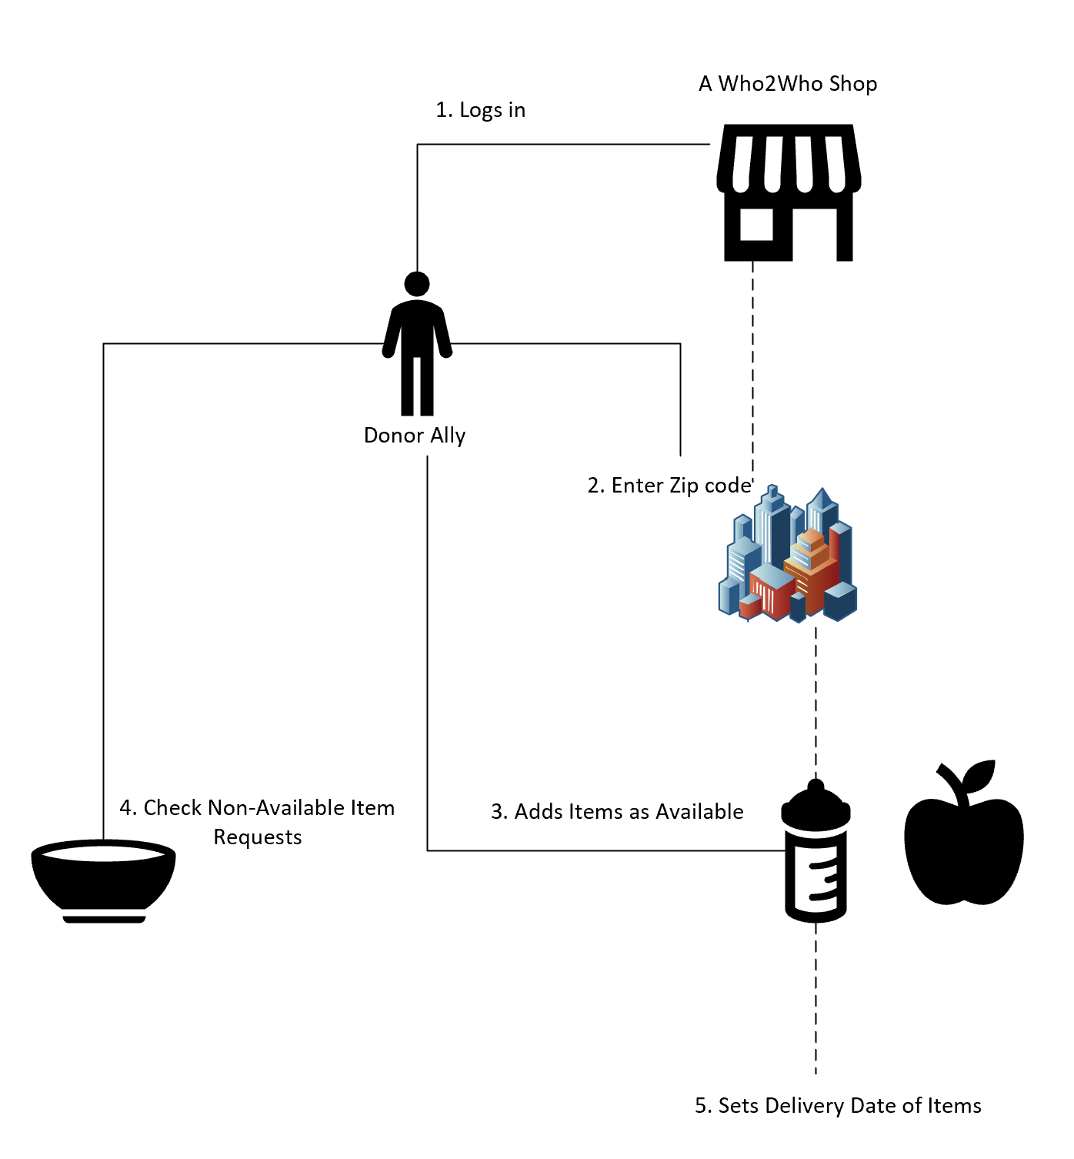

*Who 2 Who* Shop Ally Flow

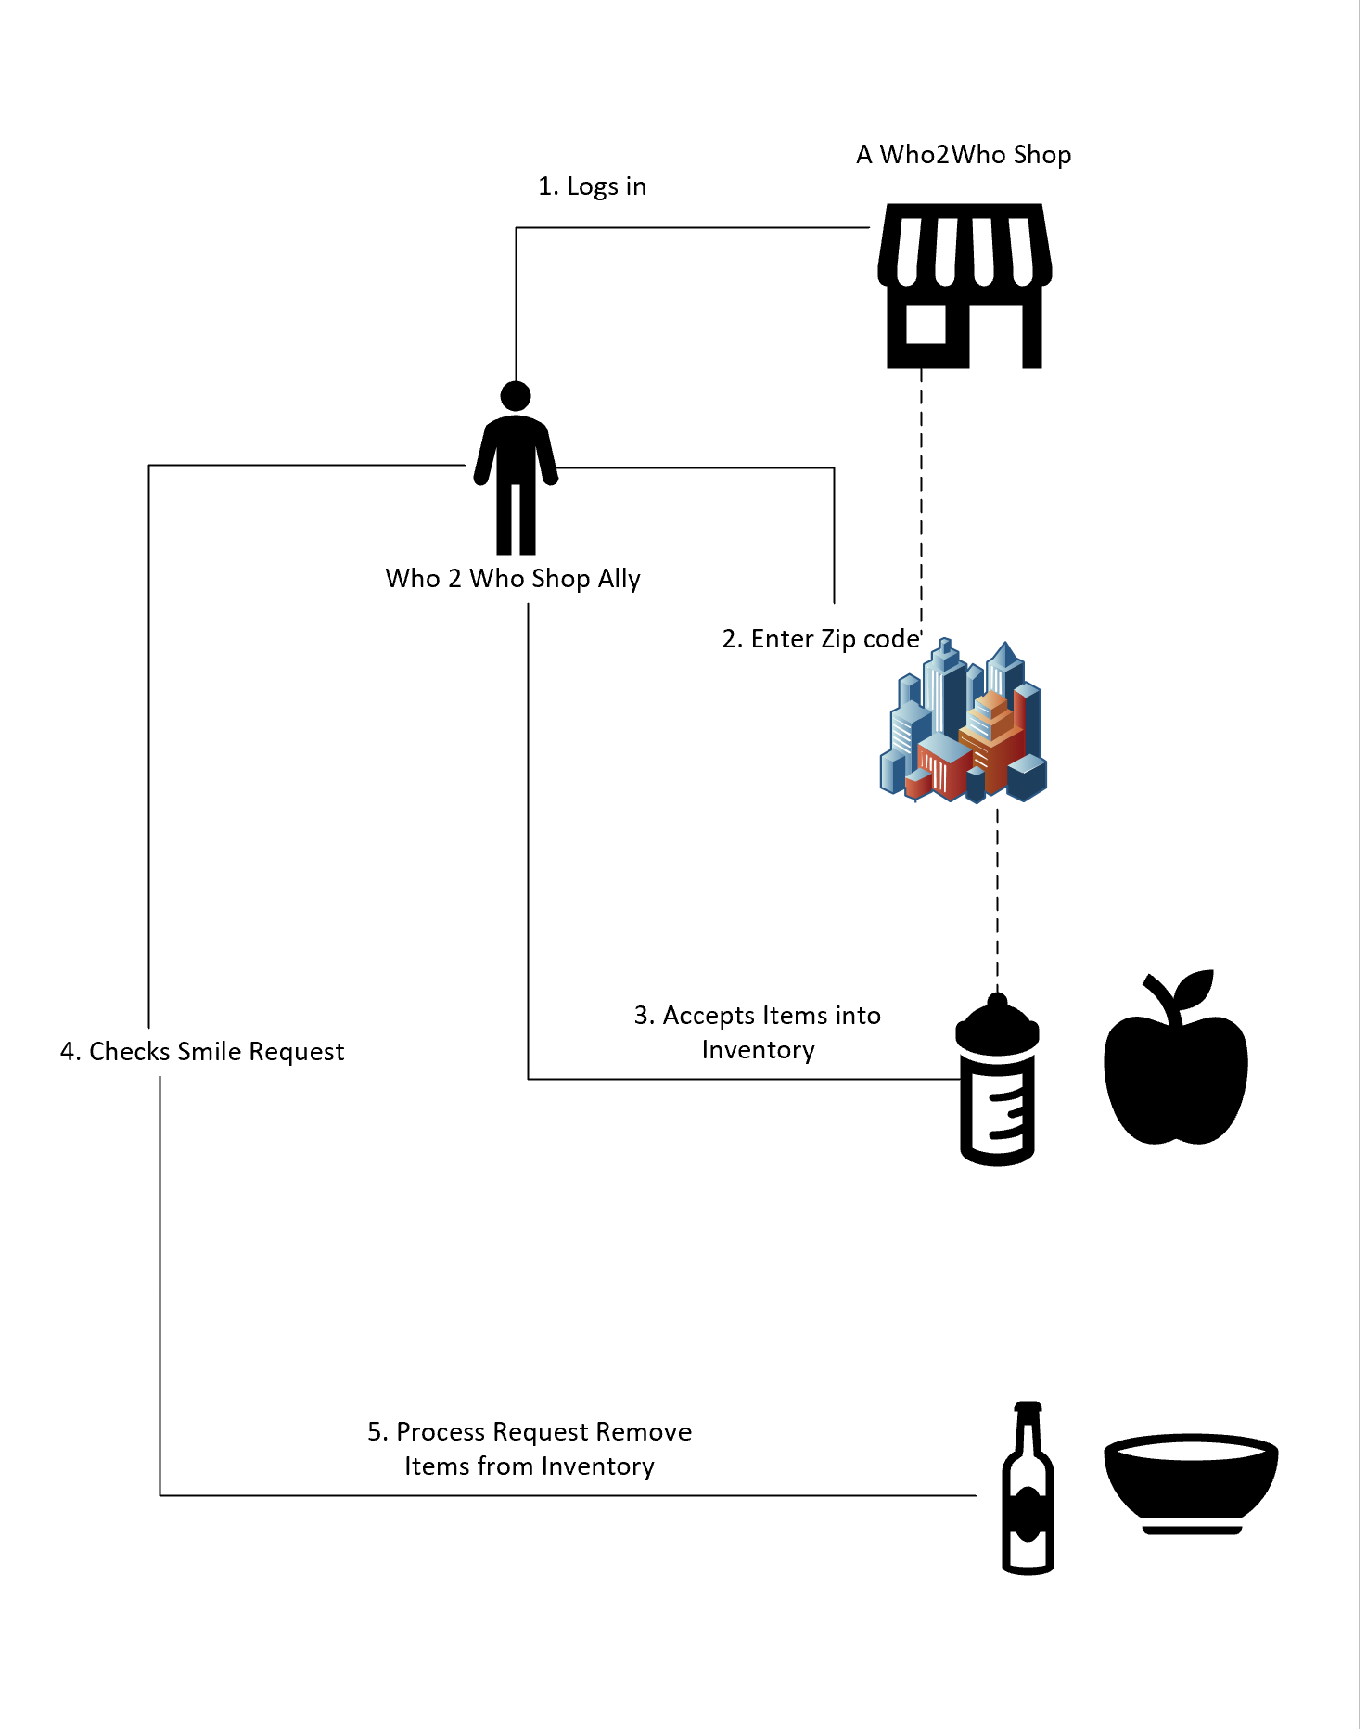

The WestCoast Team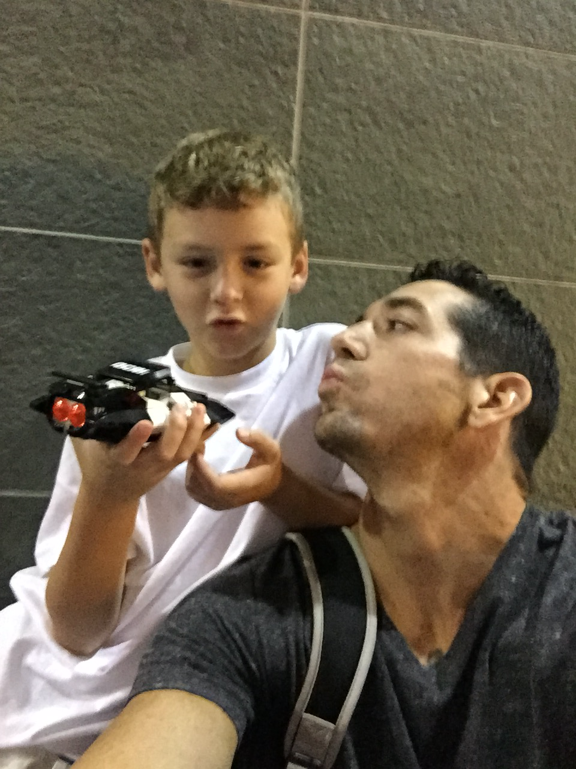

Christian Dunham

Former United States Special Forces Detachment Commander. Masters Candidate in Cybersecurity Engineering. I have been a recipient of *Who 2 Who* 3 times in my life. Lived on WIC and Food Stamps at two points in my life.